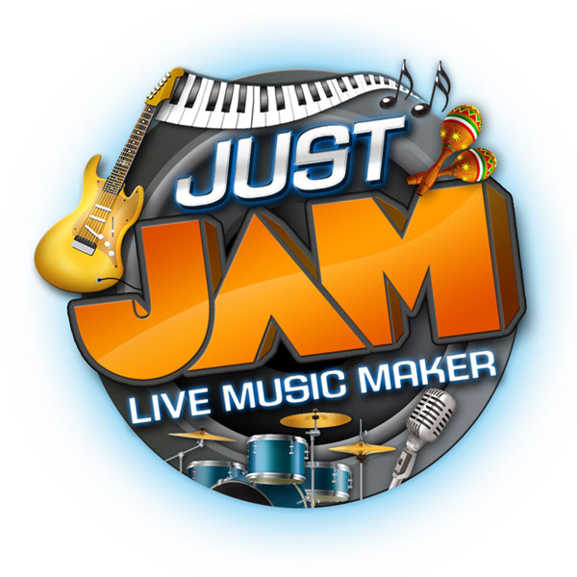
Zivix Invites Wii Owners to JustJam & Feel The Groove This Summer
Do you like Music? It’s time to make some serious noise with Zivix’s innovative music creation/rhythm video game launching on WiiWare July 7, 2011!
Minneapolis, Minnesota – June 28, 2011 – Zivix Interactive and Big John Games announced today JustJam, their upcoming music creation/rhythm-video game hybrid coming as a digital download for the WiiTM. Available for download on the WiiwareTM service this July 7th, JustJam is an all new type of freeform rhythm game that lets players create their own musical mix across top genres including pop, rock, techno, alternative and hip hop tracks.
JustJam for WiiWare lets you be the band, mix and remix live music instantly. With your Wii Remote™, you can control 16 live jam’s featuring hundreds of exciting music tracks and sounds. Anyone can pick up and play music using either of two unique play styles that make it fun and easy to mix music live. Jam with music featuring your favorite genres and cool artists throughout six creative visual venues, as you score points and unlock content as you go.
“Many popular music-based games have lost their groove, but we continue to see a new breed of music gaming emerge, with dancing and singing features bringing more players back into the fold.” said Chad Koehler, Vice President of Zivix. “JustJam provides a completely new approach that brings the player even closer to the music where they can truly interact with the music, not just listen.”
JustJam was created to get everyone immediately playing with live music. There is nothing quite like JustJam; at the snap of the Wii Remote you launch a guitar riff, a drum beat, or maybe some sound effects and vocals. Perform in the living room and show off your skills or simply kick back and relax to millions of musical combinations!
JustJam for WiiWare Features:
- 16 Music Tracks (Jams)
- 6 Dynamic Venues flowing to your tune
- Play with the Mixing board or go Freestyle
- Save, Edit and Remix your Performance
- Multiple Profiles
- Share your performance by saving on the Wii Remote
- Gain Experience Points and unlock more musical power
- New Downloadable Jams
JustJam will be launching on WiiWare in July 7, 2011 and is rated ‘E’ for Everyone. For more information about JustJam and other Zivix music products please ‘Like’ us on Facebook, follow us on Twitter or visit us at www.zivix.net. Also, check out the Jam Music Network of products at http://jammusicnetwork.com/JustJamWii.html.
For more information including the JustJam trailer and screen shots visit http://www.bigjohngames.com/games/just-jam

###

About Zivix
Zivix, LLC combines innovation, technology and entertainment through gaming software and music peripherals. Based in Minneapolis, MN, Zivix is an entertainment software developer and publisher that has also created a patented finger-sensing technology that enables a new generation of digital guitars. Our core mission is to converge the experience of playing an instrument and real musical interaction through accessible, fun and rewarding products for everyone. For more information, please visit www.jammusicnetwork.com or www.zivix.net.
About Big John Games
Big John Games is an independently owned video game development studio located in Edina, Minnesota. Its team of game designers, engineers, artists, and animators are dedicated to developing great games for all audiences. Over the years, the Big John Games staff has partnered with leaders in the game publishing industry to produce numerous successful video entertainment products. Big John Games is proud to be an authorized developer for the Nintendo DS™, Nintendo 3DS™, and Wii™ systems.
Zivix Media Contact
Reverb Communications
Steven Hopper
steven@reverbinc.com
(209) 586-1495 x110

